
Worthing College (65355)
Candidate Name: Emma Coe
Candidate Number:
Storyboard Title: Dystopian Film

1
 | 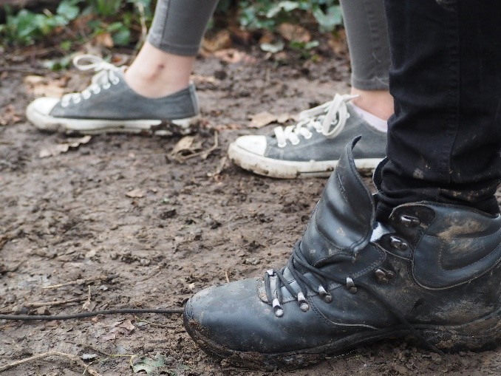 | Slug Line: EXT- Pine forest- Winter
 |  | Action: 2 Sets of footprints in the woods
 |  | Camera: Close up- Low angle
 |  | Dialogue: None
 |  | Sound: Leaves crunching, heavy footsteps and breathing
 |  | Transition: Cut
 |  | Duration: est. 4 seconds
2
 | 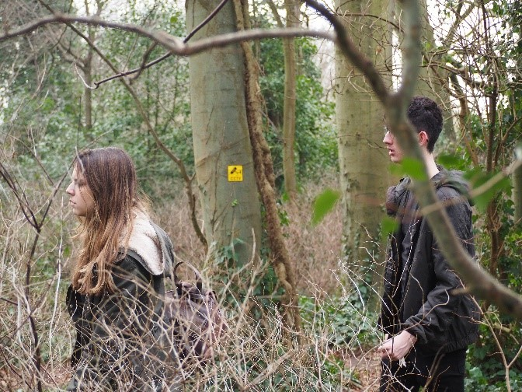 | Slug Line: EXT- Pine forest- Winter
 |  | Action: Jess and Liam run through forest- their faces obscured by the trees
 |  | Camera: Long shot
 |  | Dialogue: None
 |  | Sound: Trees, footsteps, leaves, foliage, heavy breathing
 |  | Transition: Cut
 |  | Duration: est. 6 seconds
3
 | 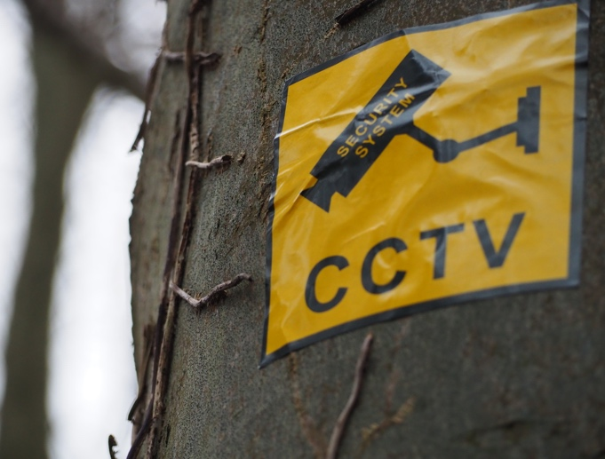 | Slug Line: EXT- Pine forest- Winter
 |  | Action: CCTV camera warning
 |  | Camera: Mid-shot- Low angle
 |  | Dialogue: None
 |  | Sound: Trees, footsteps, leaves, foliage, heavy breathing
 |  | Transition: Cut
 |  | Duration: est. 2 seconds

4
 | 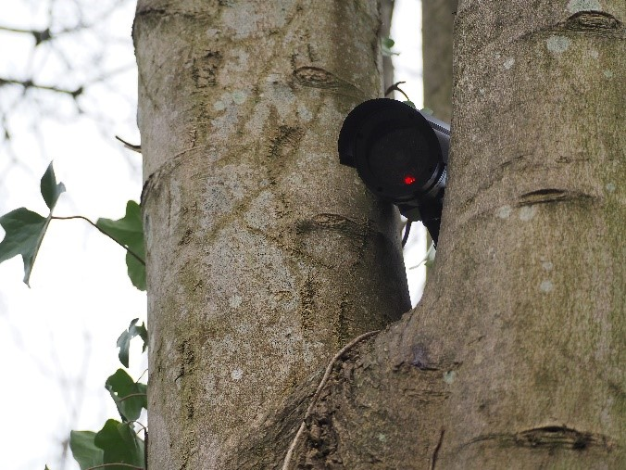 | Slug Line: EXT- Pine forest- Winter
 |  | Action: Security camera flashing red
 |  | Camera: Mid-shot- Low angle
 |  | Dialogue: None
 |  | Sound: Heavy breathing, zoom in of security camera lens
 |  | Transition: Cut
 |  | Duration: est.3 seconds
5
 |  | Slug Line: EXT- Pine forest- Winter
 |  | Action: Jess drops knife in surrender
 |  | Camera: Long shot - High angle, wide lens (CCTV)
 |  | Dialogue: None
 |  | Sound: Close sonic perspective- Knife falling on floor, heavy breathing
 |  | Transition: Cut
 |  | Duration: est.4 seconds
6
 | 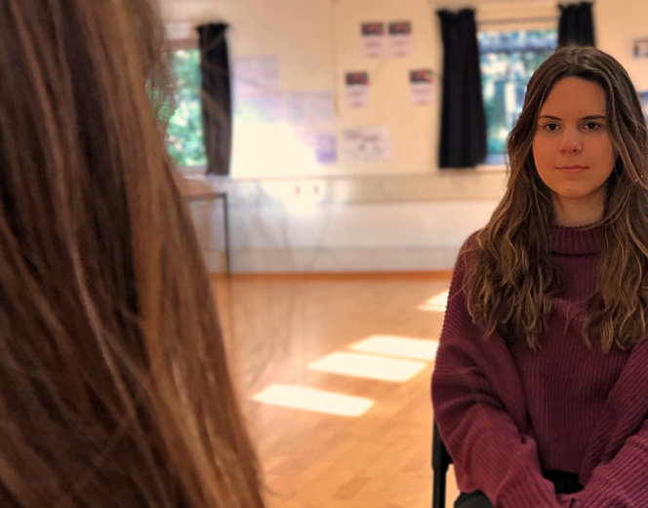 | Slug Line: INT- Government interrogation room
 |  | Action: Jess sits at table in interrogation room looking in mirror
 |  | Camera: Establishing shot
 |  | Dialogue: None
 |  | Sound: Jess breathing, Clock ticking
 |  | Transition: Cut
 |  | Duration: est. 6 seconds

7
 | 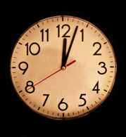 | Slug Line: INT- Government interrogation room
 |  | Action: Clock ticks as time passes
 |  | Camera: Extreme close up
 |  | Dialogue: None
 |  | Sound: Jess breathing, Clock ticking
 |  | Transition: Cut
 |  | Duration: est.7 seconds
8
 | 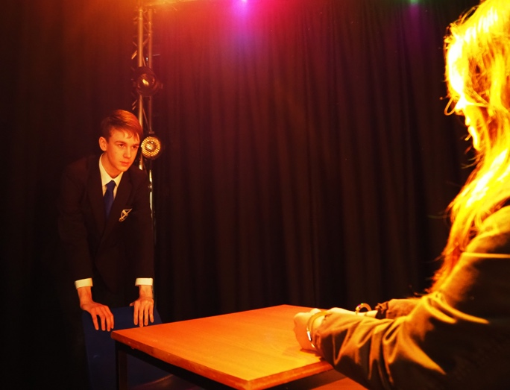 | Slug Line: INT- Government interrogation room
 |  | Action: Clive enters room
 |  | Camera: Mid-shot- Jess POV over shoulder
 |  | Dialogue: ‘Where is he?...’
 |  | Sound: Door opening and closing, handcuffs against metal table
 |  | Transition: Cut
 |  | Duration: est. 20 seconds
9
 | 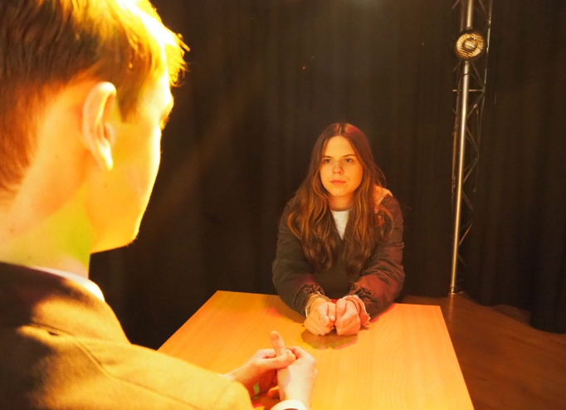 | Slug Line: INT- Government interrogation room
 |  | Action: Clive sits down
 |  | Camera: Mid-shot- Clive over the shoulder shot
 |  | Dialogue: ‘That’s what I have you for…’
 |  | Sound: Clock. Metal of handcuffs against table.
 |  | Transition: Cut
 |  | Duration: est. 20 seconds

10
 | 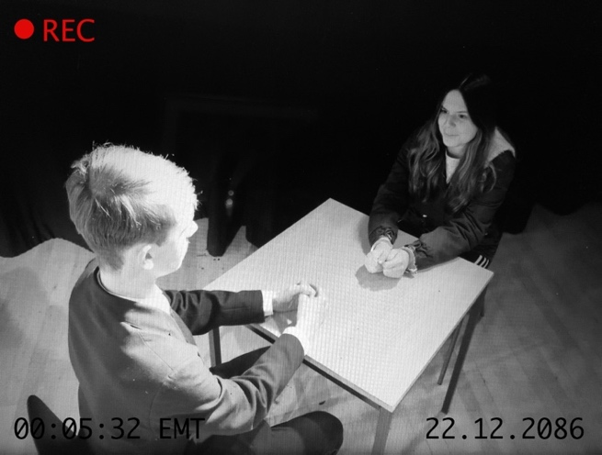 | Slug Line: INT- Government interrogation room
 |  | Action: Clive sits down, Jess straightens in her chair
 |  | Camera: Long shot - High angle, wide lens (CCTV)
 |  | Dialogue: ‘I tried to be free…’
 |  | Sound: Security camera switches off
 |  | Transition: Cut
 |  | Duration: est. 20seconds
11
 |  | Slug Line: INT- Government interrogation room
 |  | Action: Jess tries to get up- talking to Clive
 |  | Camera: Close up of Jess’s hands handcuffed
 |  | Dialogue: ‘Fine. I’ll tell you. But first, un-cuff these…’
 |  | Sound: Close sonic perspective- handcuffs
 |  | Transition: Cross Fade
 |  | Duration: est.10 seconds
12
 | 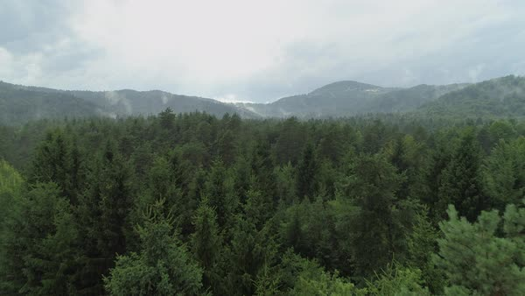 | Slug Line: EXT- Pine forest- Winter- (Flashback
 |  | Action: Pine forest
 |  | Camera: Establishing shot
 |  | Dialogue: None
 |  | Sound: Leaves crunching, heavy footsteps and breathing
 |  | Transition: Cut
 |  | Duration: est. 4 seconds

13
 | 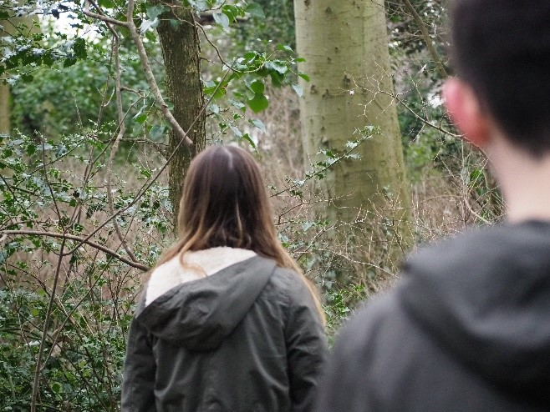 | Slug Line: EXT- Pine forest- Winter
 |  | Action: Liam walking behind Jess
 |  | Camera: Close up- Liam POV over shoulder
 |  | Dialogue: ‘Please slow down, we’ve been walking for miles…’
 |  | Sound: Leaves/trees footstep + heavy breathing
 |  | Transition: Cut
 |  | Duration: est.20 seconds
14
 | 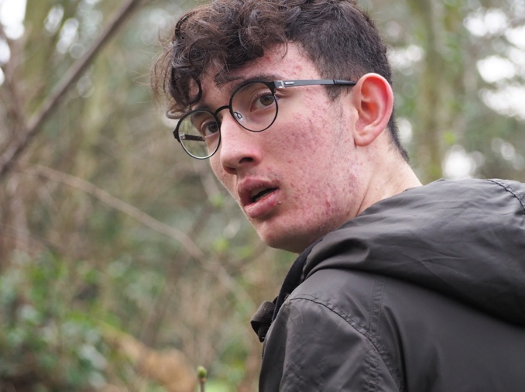 | Slug Line: EXT- Pine forest- Winter
 |  | Action: Liam looks behind him paranoid
 |  | Camera: Close up of Liam
 |  | Dialogue: None
 |  | Sound: Close sonic perspective - Liam breathing heavily
 |  | Transition: Cut
 |  | Duration: est. 4 seconds
15
 | 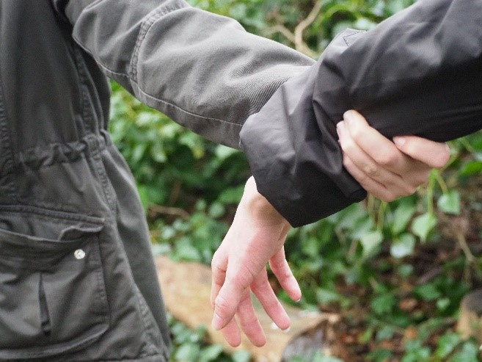 | Slug Line: EXT- Pine forest- Winter
 |  | Action: Jess grabs Liam’s arm as they walk
 |  | Camera: Close up
 |  | Dialogue: ‘Miles isn’t good enough Liam…’
 |  | Sound: Close sonic perspective- hand grabbing coat
 |  | Transition: Cut
 |  | Duration: est.30 seconds

16
 | 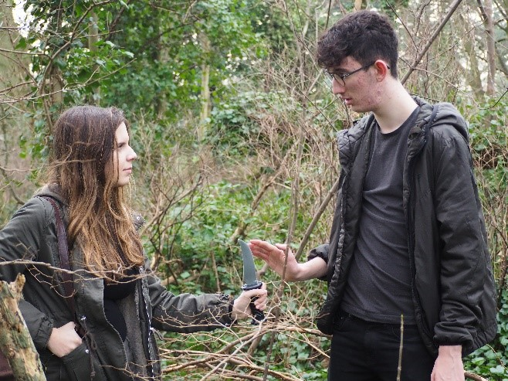 | Slug Line: EXT- Pine forest- Winter
 |  | Action: Jess tries to give Liam knife- he refuses
 |  | Camera: Mid-shot- Centered frame
 |  | Dialogue: ‘Just take it, for my piece of mind…’
 |  | Sound: Close sonic perspective- Knife blade
 |  | Transition: Cut
 |  | Duration: est. 15 seconds
17
 | 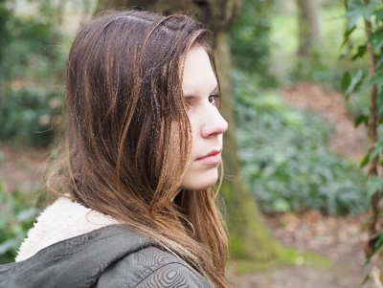  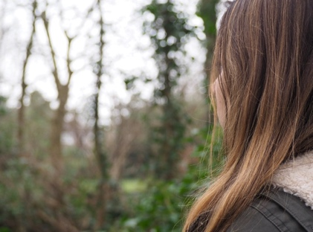 | Slug Line: EXT- Pine forest- Winter
 |  | Action: Jess turns around to look at empty forest
 |  | Camera: Close up- Jess POV over shoulder shot
 |  | Dialogue: None
 |  | Sound: Trees and leaves
 |  | Transition: Cut
 |  | Duration: 15 seconds
18
 | 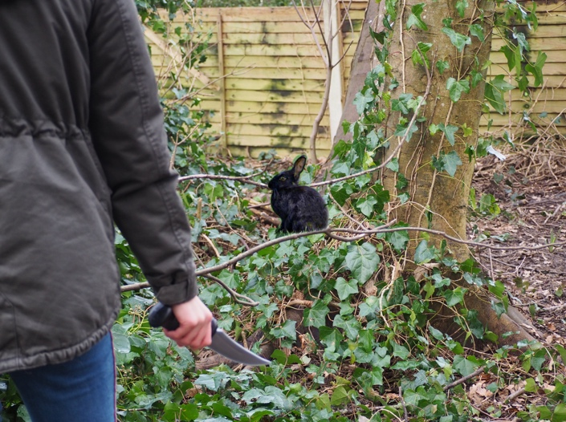 | Slug Line: EXT- Pine forest- Winter
 |  | Action: Jess Spots a rabbit and grips her knife tightly
 |  | Camera: Mid shot- Foreground soft focus
 |  | Dialogue: None
 |  | Sound: Rabbit rustling in leaves, twig snaps.
 |  | Transition: Cut
 |  | Duration: est. 10 seconds

19
 | 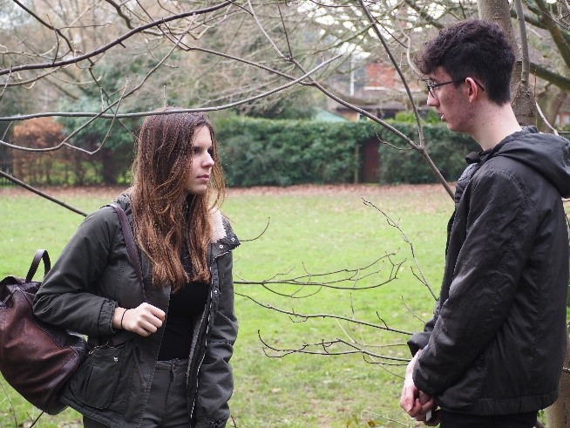 | Slug Line: EXT- Pine forest- Winter
 |  | Action: Jess and Liam reach the edge of the forest
 |  | Camera: Mid shot- centered frame
 |  | Dialogue: ‘Just as a precaution…’
 |  | Sound: Rustle of trees in distance
 |  | Transition: END
 |  | Duration: est. 40 seconds

