
Worthing College (65355)
Candidate Name: Emma Coe
Candidate Number:
Storyboard Title: Dystopian Film

1
 | 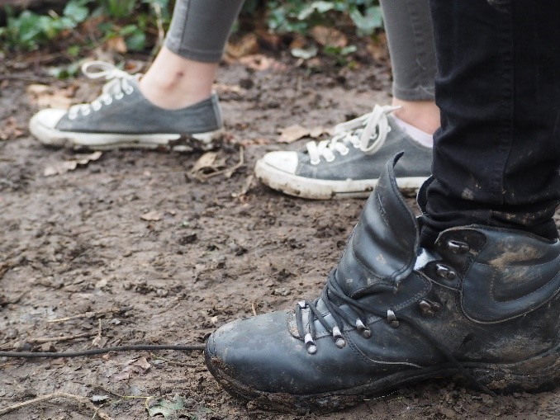 | Slug Line: EXT- Middle of pine forest- Winter
 |  | Action: 2 Sets of footprints in the woods
 |  | Camera: Close up- Low angle
 |  | Dialogue: None
 |  | Sound: Leaves crunching, heavy footsteps and breathing
 |  | Transition: Jump cut
 |  | Duration: est. 4 seconds
2
 | 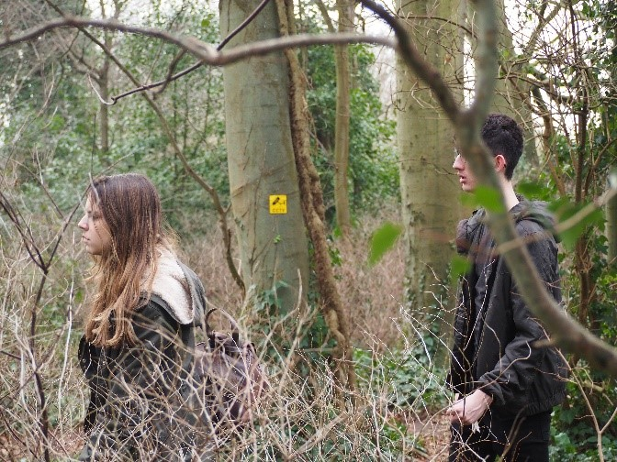 | Slug Line: EXT- Middle of pine forest- Winter
 |  | Action: Jess and Liam run through forest- their faces obscured by the trees
 |  | Camera: Long shot
 |  | Dialogue: None
 |  | Sound: Trees, footsteps, leaves, foliage, heavy breathing
 |  | Transition: Jump cut
 |  | Duration: est. 6 seconds
3
 | 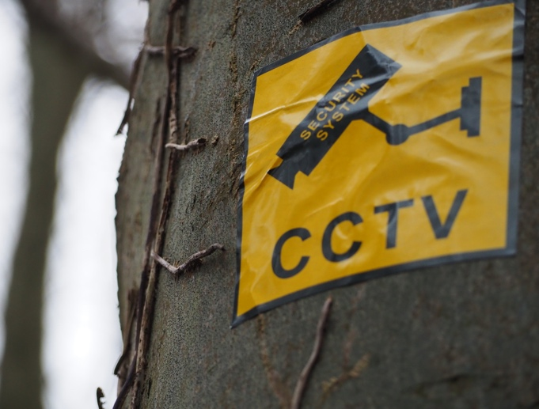 | Slug Line: EXT- Middle of pine forest- Winter
 |  | Action: CCTV camera warning
 |  | Camera: Mid-shot- Low angle
 |  | Dialogue: None
 |  | Sound: Trees, footsteps, leaves, foliage, heavy breathing
 |  | Transition: Jump cut
 |  | Duration: est. 2 seconds

4
 | 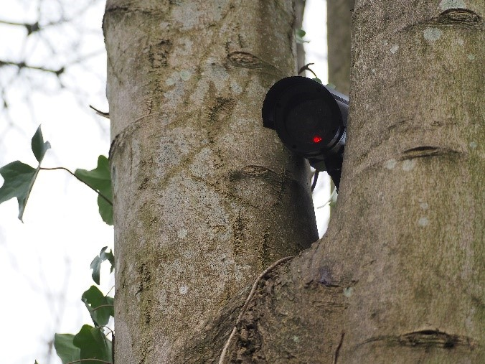 | Slug Line: EXT- Middle of pine forest- Winter
 |  | Action: Security camera flashing red
 |  | Camera: Mid-shot- Low angle
 |  | Dialogue: None
 |  | Sound: Heavy breathing, zoom in of security camera lens
 |  | Transition: Jump cut
 |  | Duration: est.3 seconds
5
 |  | Slug Line: EXT- Middle of pine forest- Winter
 |  | Action: Jess drops knife in surrender
 |  | Camera: Long shot - High angle, wide lens (CCTV)
 |  | Dialogue: None
 |  | Sound: Close sonic perspective- Knife falling on floor, heavy breathing
 |  | Transition: Jump cut
 |  | Duration: est.4 seconds
6
 |  | Slug Line: INT- Government interrogation room
 |  | Action: Clock ticks as time passes
 |  | Camera: Extreme close up
 |  | Dialogue: None
 |  | Sound: Jess breathing, Clock ticking
 |  | Transition: Jump cut
 |  | Duration: est.7 seconds

7
 | 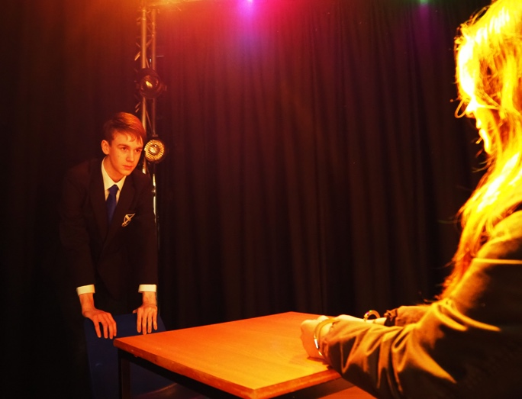 | Slug Line: INT- Government interrogation room
 |  | Action: Clive enters room
 |  | Camera: Mid-shot- Jess POV over shoulder
 |  | Dialogue: ‘Where is he?...’
 |  | Sound: Door opening and closing, handcuffs against metal table
 |  | Transition: Jump cut
 |  | Duration: est.40 seconds
8
 | 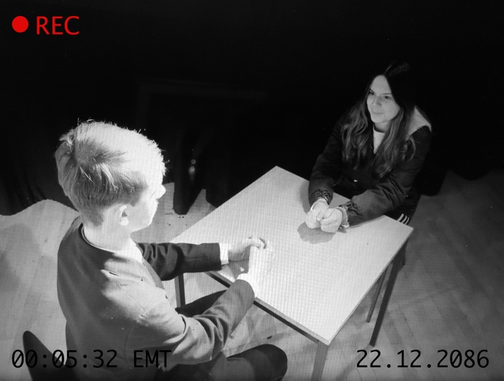 | Slug Line: INT- Government interrogation room
 |  | Action: Clive sits down, Jess straightens in her chair
 |  | Camera: Long shot - High angle, wide lens (CCTV)
 |  | Dialogue: ‘He’s smarter than you think…’
 |  | Sound: Security camera switches off
 |  | Transition: Black out into jump cut
 |  | Duration: est.10 seconds
9
 |  | Slug Line: INT- Government interrogation room
 |  | Action: Jess tries to get up- talking to Clive
 |  | Camera: Close up of Jess’s hands handcuffed
 |  | Dialogue: ‘Fine. I’ll tell you. But first, un-cuff these…’
 |  | Sound: Close sonic perspective- handcuffs
 |  | Transition: Cross Fade
 |  | Duration: est.10 seconds

10
 | 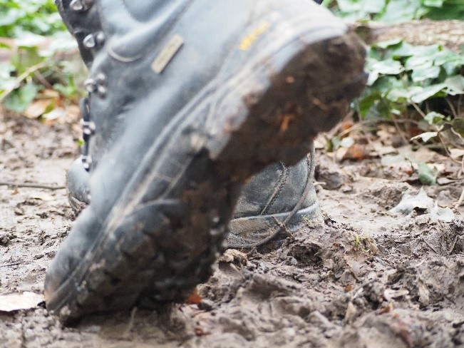 | Slug Line: EXT- Middle of pine forest- Winter- (Flashback)
 |  | Action: Liam and Jess running through forestleavng footprints
 |  | Camera: Extreme close up of footprint
 |  | Dialogue: ‘Come on, we’re almost at the edge…’
 |  | Sound: Leaves crunching, heavy footsteps and breathing
 |  | Transition: Jump cut
 |  | Duration: est. 4 seconds
11
 | 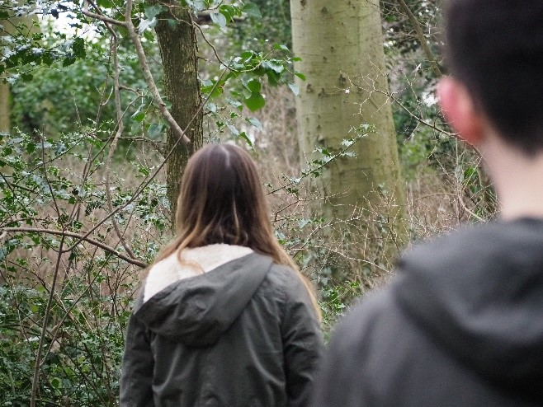 | Slug Line: EXT- Middle of pine forest- Winter
 |  | Action: Liam walking behind Jess
 |  | Camera: Close up- Liam POV over shoulder
 |  | Dialogue: ‘Please slow down, we’ve been walking for miles…’
 |  | Sound: Leaves/trees footstep + heavy breathing
 |  | Transition: Jump cut
 |  | Duration: est.20 seconds
12
 | 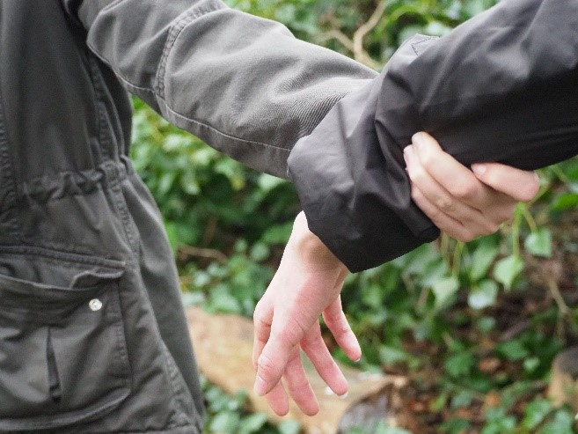 | Slug Line: EXT- Middle of pine forest- Winter
 |  | Action: Jess grabs Liam’s arm as they walk
 |  | Camera: Close up
 |  | Dialogue: ‘Miles isn’t good enough Liam…’
 |  | Sound: Close sonic perspective- hand grabbing coat
 |  | Transition: Jump cut
 |  | Duration: est.30 seconds

13
 | 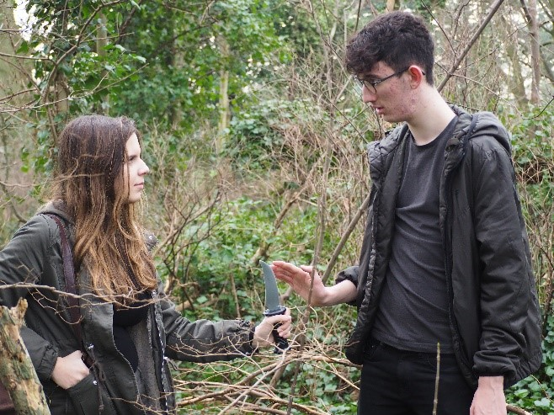 | Slug Line: EXT- Middle of pine forest- Winter
 |  | Action: Jess tries to give Liam knife- he refuses
 |  | Camera: Mid-shot- Centered frame
 |  | Dialogue: ‘Just take it, for my piece of mind…’
 |  | Sound: Close sonic perspective- Knife blade
 |  | Transition: Jump cut
 |  | Duration: est. 15 seconds
14
 | 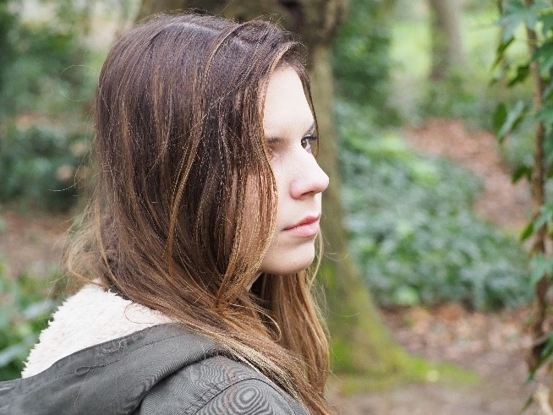 | Slug Line: EXT- Middle of pine forest- Winter
 |  | Action: Jess turns around and looks behind her at forest
 |  | Camera: Close up of Jess
 |  | Dialogue: None
 |  | Sound: Trees, leaves
 |  | Transition: Jump cut
 |  | Duration: est.5 seconds
15
 | 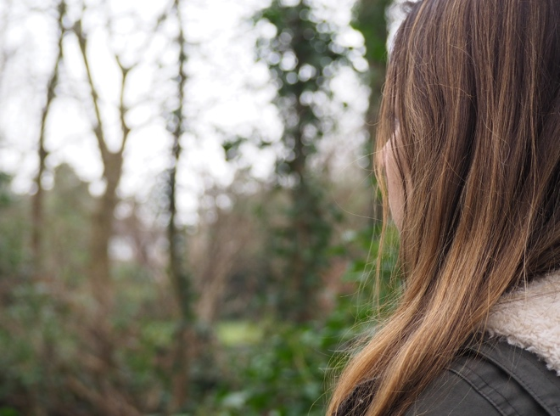 | Slug Line: EXT- Middle of pine forest- Winter
 |  | Action: Jess looks into the empty forest, spots a black rabbit
 |  | Camera: Close up- Jess POV over shoulder
 |  | Dialogue: None
 |  | Sound: Trees, leaves, heavy breathing
 |  | Transition: Jump cut
 |  | Duration: est.7 seconds

16
 | 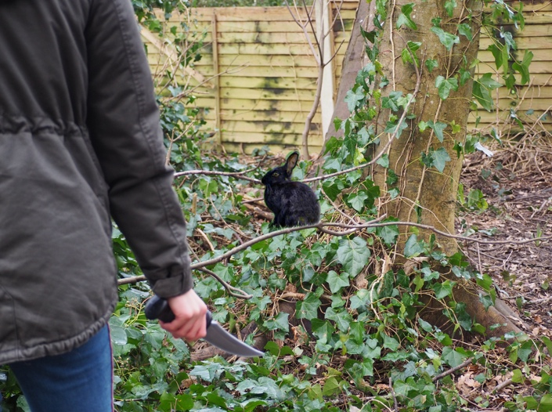 | Slug Line: EXT- Middle of pine forest- Winter
 |  | Action: Jess grips her knife in her hand and stares at the rabbit
 |  | Camera: Mid shot- Foreground soft focus
 |  | Dialogue: None
 |  | Sound: Rabbit rustling in leaves, heavy breathing
 |  | Transition: Jump cut
 |  | Duration: est. 10 seconds
17
 | 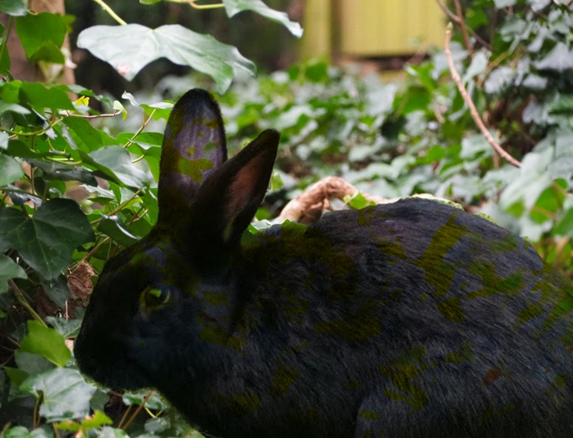 | Slug Line: EXT- Middle of pine forest- Winter
 |  | Action: Twig snaps under Jess’s foot. Rabbit runs away into hollow log
 |  | Camera: Extreme close up
 |  | Dialogue: None
 |  | Sound: Twig snap, leaves rustle
 |  | Transition: Jump cut
 |  | Duration: est.5 seconds
18
 | 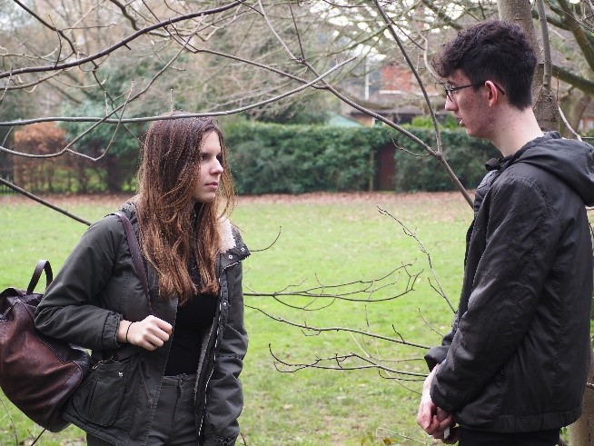 | Slug Line: EXT- Middle of pine forest- Winter
 |  | Action: Jess tries to give Liam drug as they reach the edge of the forest
 |  | Camera: Mid shot- centered frame
 |  | Dialogue: ‘Just as a precaution…’
 |  | Sound: Rustle of trees in distance
 |  | Transition: END
 |  | Duration: est.40 seconds

